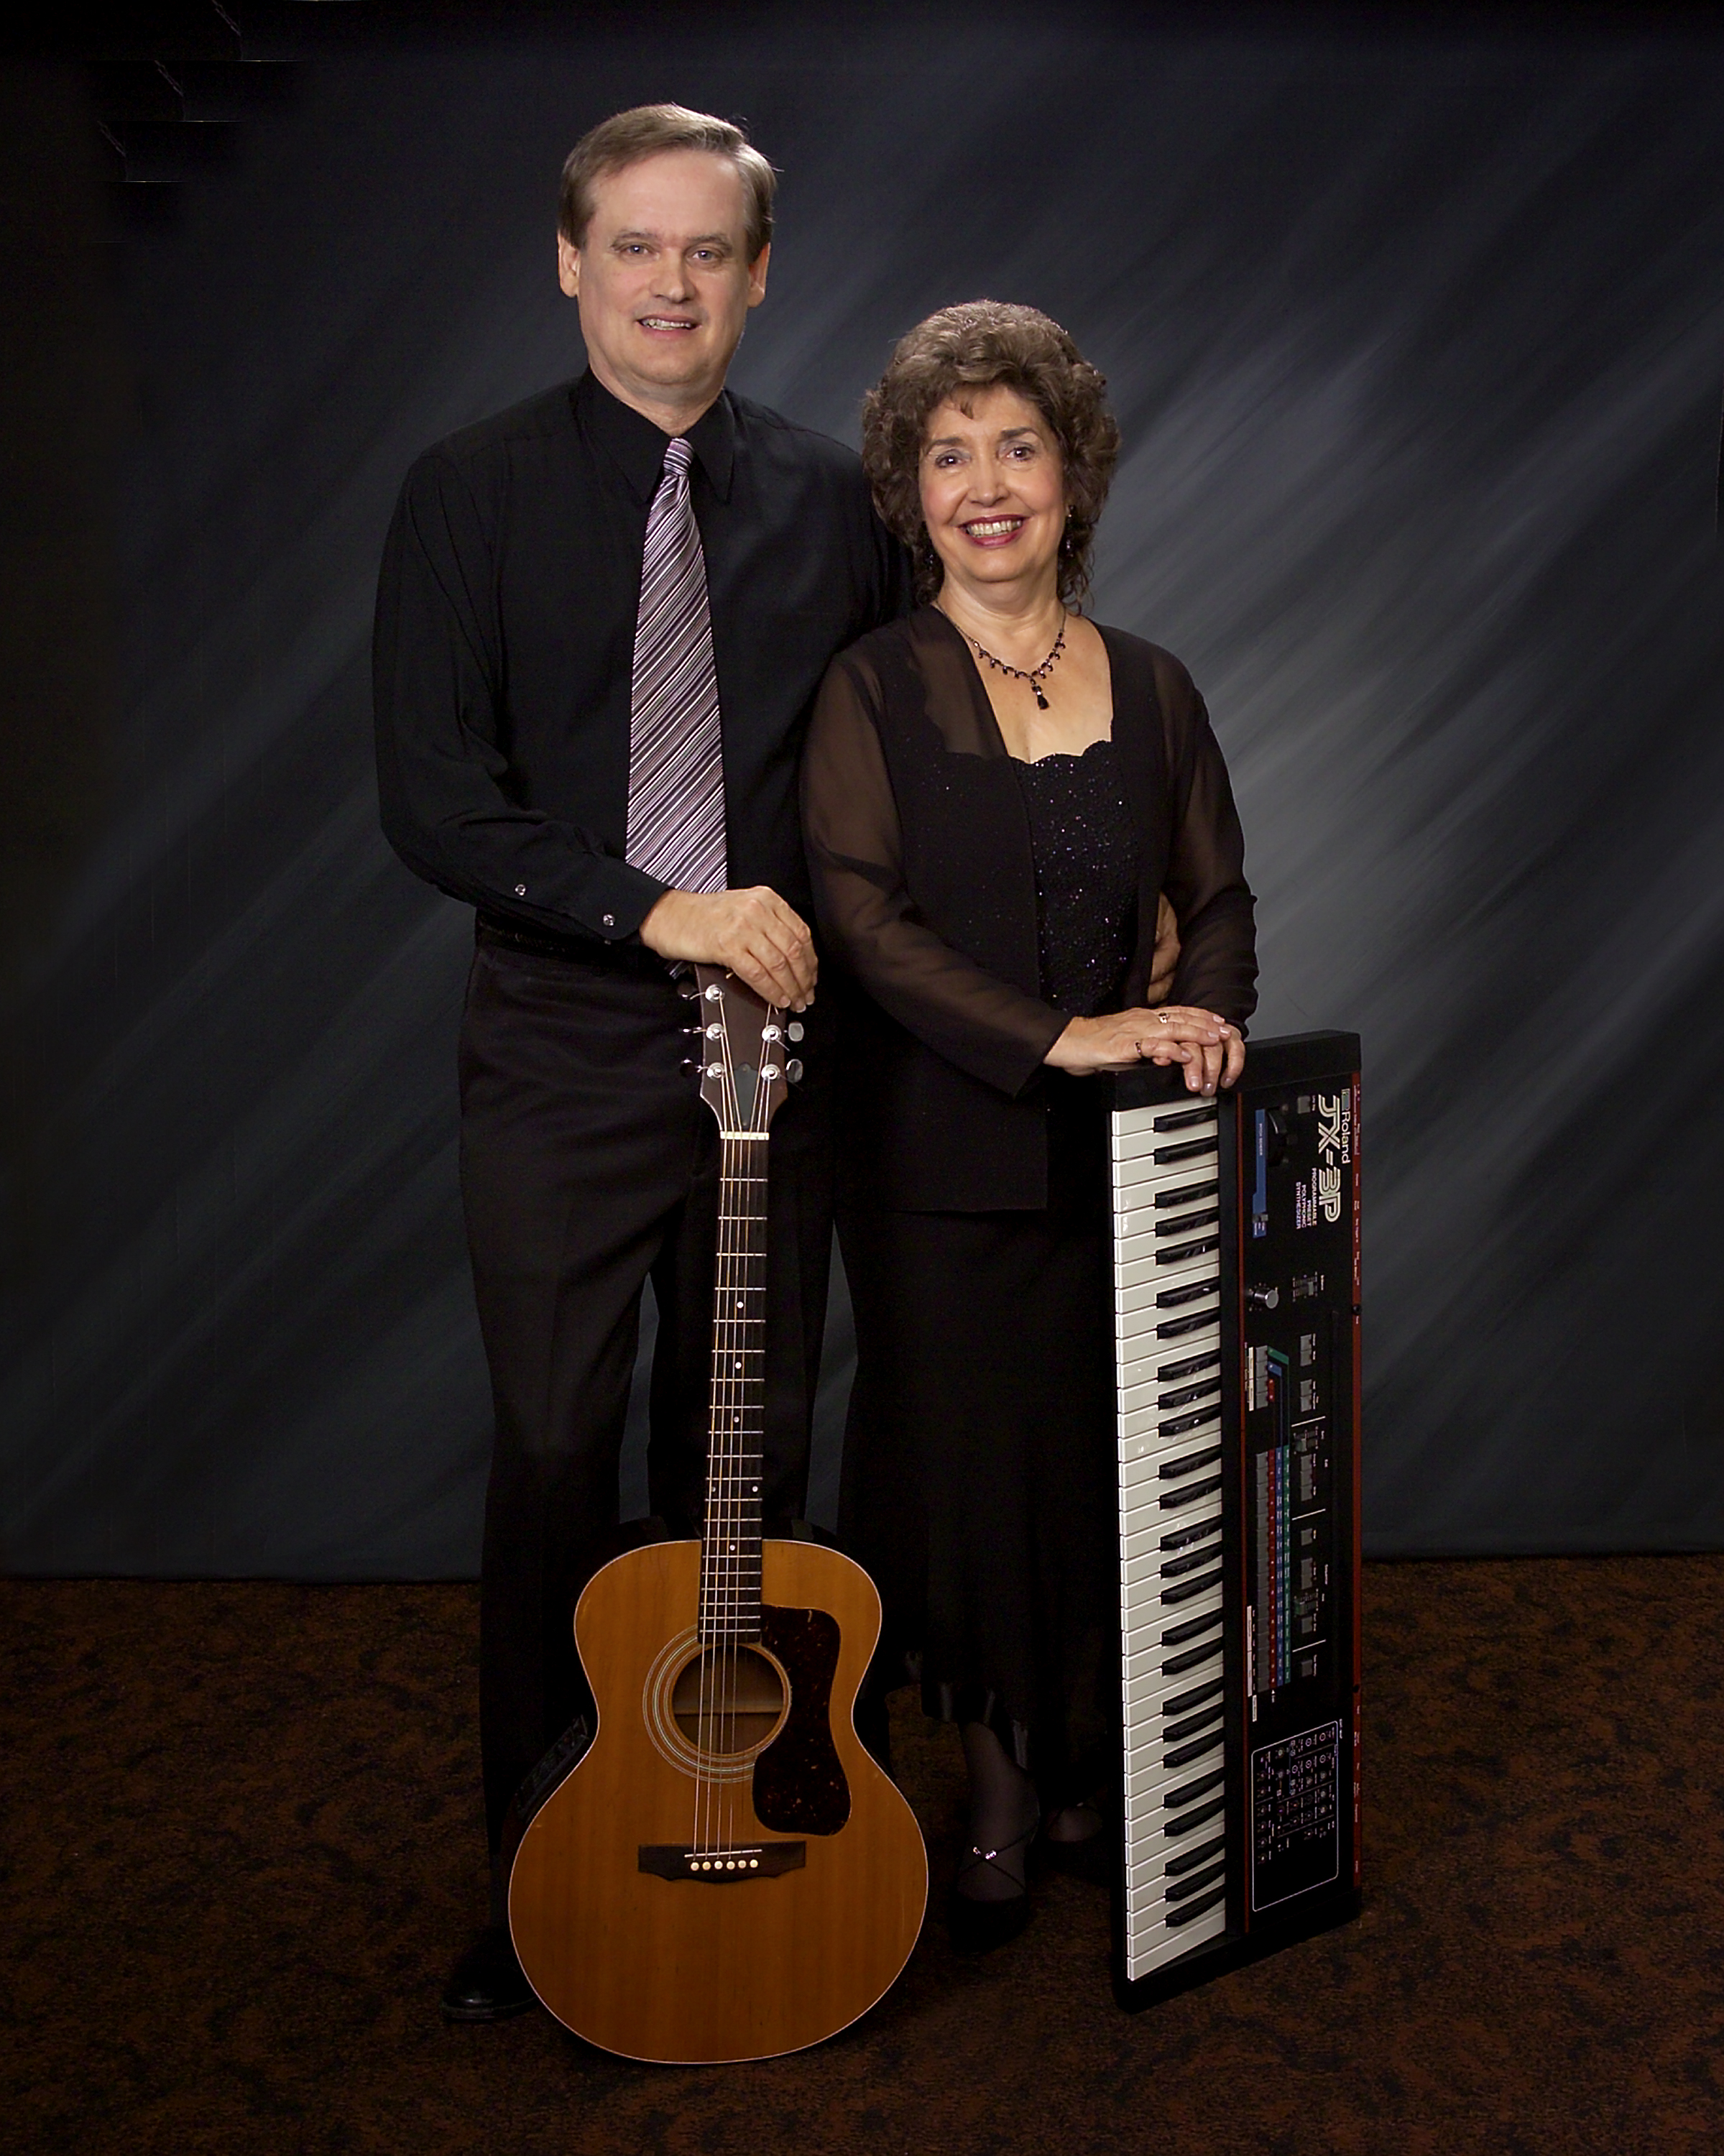

BOB PUFFER spent 13 years in country music, beginning his music career in the nightclub business where he made significant progress toward a lucrative future as a performer and song writer. He succeeded in passing an audition to appear on the national television show, HEEHAW. He later contracted for a major concert where he shared billing with the OAKRIDGE BOYS. He was often interviewed as an up-and-coming Country Music personality and had the honor of being written up in MUSIC CITY NEWS, the most widely distributed country music news magazine in the nation. With all this success, Bob was not content and knew something was “missing” in his life. Some personal disillusionment and his mother’s illness further influenced him, along with the salvation of his friend and Holiday Inn Manager, Gary Welling (who later became his pastor).

After leaving the nightclub business and seeking God’s will, Bob met and married Darleen, who added a new dimension to the ministry. Bob can hold the attention of those who see him with a multitude of instruments, including acoustic guitar, five-string banjo, violin, mandolin, chet atkins guitar, dobro and ukulele. God has blessed him with over 400 original songs, which are interspersed with other familiar songs. Darleen adds her talents on keyboard, harmonies, and sax. You will hear a diversified program, ranging from lively instrumentals to southern gospel, country, folk, traditional and comedy.

Bob & Darleen, known as “The Puffers”, have traveled extensively throughout the U.S. and Canada. Their songs have been played on TV and numerous radio stations. Most recently, their song “Noah Had A GPS” made #l on the March 2014 National Christian Country Chart and #2 on the International Chart. Other #1 songs have been “The Boat Cannot Sink” on the International Gospel Chart in 2008, “It’s Good But It’s Gonna Get Better” on the National Christian Country Chart in 2009, along with a #2 song by Darleen “Up In Glory” on the National Christian Country Chart! They haved shared the platform with such groups as The Anchormen, Dixie Melody Boys, The Dixie Echoes, The Weatherfords, Lorne Mathews, and many others.

Look for the music of “The Puffers” online at www.thepuffers.com. You can also find some of their music on iTunes and CD Baby.

“The Puffers” will be appearing locally through the courtesy of:

SPONSOR NAME_____________________________________________________________

At LOCATION________________________________________________________________

ON (DATE & TIME)___________________________________________________________
(Enter additional desired into here; ideas? Will there be nursery care? Parking? Free will offering? Tickets?

(NAME)________________________________________says the whole community is invited!

